How To Identify Midfakes

In this document we will be documenting all midfake identifiers in one document.
For those who are unaware of what a midfake is, let’s dive into it.

  - What is a midfake?

A midfake is a high-quality reproduction of Takara Tomy’s popular Metal Fight series.
Ever since its stop in production between 2012 and 2016, a market started brewing with counterfeit beyblades that were very close to their originals. Midfakes, unlike their fake counterparts do not contain any lead, which makes them safe to handle.
Now that we have established on what a midfake is, let’s discuss how to tell if a Beyblade is midfake or not.
The difference between a midfake and a fake fake is very clear, see references below:

The differences in box art are instantly noticeable
  - Notice
Before we begin this list of things to look out for, there is a one dead giveaway in a Beyblade that is the same across any midfake no matter which bey it is trying to replicate. (Image below sourced from the internet)
There is a code inside the facebolt, if they bey you are looking at doesn’t have one, it is 100% not an authentic facebolt and should make you question the bey’s authenticity.
Reference on where the code is:

The facebolt has 2 sides so make sure to check on which side the code is.
  - Storm Pegasus 105RF

Storm Pegasus has a rubber tip known as RF (Rubber Flat).
There is a clear way to stablish if you’re looking at a midfake Storm Pegasus or not.

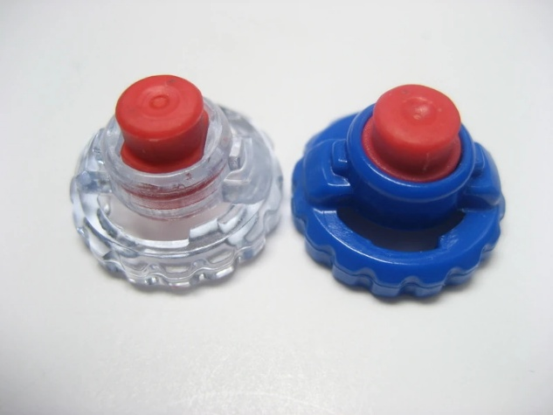
Here is a picture of a real RF:

The indentation on the tip is a very strong indicator of authenticity
The midfake rubber is more plastic-like and the indentation is either not their or not very well polished.

For the best differentiation check out this video:

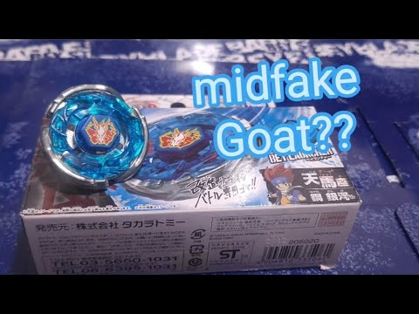

  - Rock Leone 145WB

For Rock Leone from what I could find, the facebolt sticker is a bit blurred or pixelated. Shiny metal wheels are still a factor to recon with, overall, my verdict is to ask for pictures of the facebolt code.

Image source: Reddit @ https://www.reddit.com/r/BeybladeMetal/comments/197anff/rock_leone_midfake/

  - Flame Saggitario C145S

